**Site Provisioning**

The architecture of Euro Mechanical is as follows.

QDMS

EMEC Hub

Main Hub site

Project N

Project 2

Project 1

* It contains a Main EMEC Hub site collection, a single QDMS site collection and n number of Project workspace site collections. Site collections such as EMEC Hub and QDMS are only provisioned one time and it can be done through PnP provisioning in PowerShell where lists and Site Pages are provisioned.
* But in the case of projects multiple project workspaces needed to be created once an item in Projects list is created. Each project site needs to be provisioned with the same list and pages.
* The drawback of using PnP is we need to leverage the use of Azure function apps in order to run the PnP PowerShell scripts.
* The provisioning of workspaces here is achieved using site designs and using Logic Apps.
* A project base site is created with required lists and pages. A master list is created in the site which contains the information of all lists in site as lookup columns.
* Based on the information a unique site design id is generated using PowerShell which contains information about lists, views, regional settings, groups etc. But the information on pages will not be available and this is achieved here using copying site pages from the base site using Logic apps. Also, the permissions on each list and pages will not be available in site design id. This is also achieved here using Azure Logic apps.

**Generating Site design Id**

Open Power Shell and run the following commands:

**Install SPO module** (One time installation)

Install-Module -Name Microsoft.Online.SharePoint.PowerShell

* **Connect dev site**

$username = " dev12@4n37nt.onmicrosoft.com"

$password = " CIS@2022"

$tenantAdminUrl = "https://4n37nt-admin.sharepoint.com"

$encPwd = ConvertTo-SecureString -String $password -AsPlainText –force

$newCred = New-Object -TypeName System.Management.Automation.PSCredential -ArgumentList $username,$encPwd

#Connecting the admin url

Connect-SPOService -Url $tenantAdminUrl -Credential $newCred

**If Multifactor Authentication**

Connect-SPOService -Url <https://euromechanical-admin.sharepoint.com>

* **Define master list url**

$listUrl = “<https://ccsdev01.sharepoint.com/sites/ProjectTemplate/Lists/MasterList/AllItems.aspx”>  //URL may vary according to template site

* **Set the content from master list which includes all list content to a local path**

$extracted = Get-SPOSiteScriptFromList -ListUrl $listUrl

Set-Content -Path D:\Sharepoint\Euromechanical\SiteDesign_Euro\ Filename.json -Value $extracted

* **.A json file will be created in the local path which contains information about the site. This information is listed as verbs**

Eg:

{

"verb": "addSPView",

"name": "All Items",

"viewFields": [

"LinkTitle",

"ID",

"DocumentID",

"WorkflowStatus",

"Revision",

"RequestedDate",

"DueDate",

"SourceDocumentID",

"DocumentIndexID",

"DocumentIndex",

"Reviewers",

"Approver",

"Requester",

"RequesterComment",

"PreviousReviewHeader",

"Workflow",

"ReviewedDate",

"ApprovedDate",

"Owner",

"DocumentController",

"DCCCompletionDate",

"PublishFormat",

"RevisionLevel",

"RevisionCoding",

"TransmittalRevision",

"AcceptanceCode",

"RetentionPeriod",

"ApproveInSameRevision"

],

"query": "<OrderBy><FieldRef Name=\"ID\" Ascending=\"FALSE\" /></OrderBy>",

"rowLimit": 30,

"isPaged": true,

"makeDefault": true,

"formatterJSON": "",

"replaceViewFields": true

}

]

},

Based on our requirement we edit the Json and include verbs like regional settings, join hub site etc. For more information <https://docs.microsoft.com/en-us/sharepoint/dev/declarative-customization/site-design-json-schema\>

* **Extract content from Json**

$extracted = Get-Content -Path D:\Sharepoint\Euromechanical\SiteDesign_Euro\Filename.json | Out-String

* **Get site script id**

Add-SPOSiteScript -Title "<Title>" -Content $extracted -Description "<Description>"

* **Get site design using site script**

Add-SPOSiteDesign -Title "projectTemplate" -WebTemplate "64" -SiteScripts 1b58aad4-acf2-496d-bbdb-47ebd52a3ccb -Description "Template for Project"

* **To apply site design to existing site**

Add-SPOSiteDesignTask -SiteDesignId 5ebb7fea-0fba-4340-9759-dd1090ea87da -WebUrl <https://ccsdev01.sharepoint.com/sites/projecttest>

* **To update existing list/libraries**

Invoke-SPOSiteDesign -Identity 5c517dde-80c2-49fe-8a84-e98e6e9f1f08 -WebUrl <https://euromechanical.sharepoint.com/sites/Project_Prosite5>

*In our case we are generating 2 site design ids by splitting the extracted Json in to two and generating individual site design ids for each Json. This is because there is a limitation on the number of verbs to be included in a Json.*

The site design id is then updated in SiteDesignSettings list in EMEC Hub

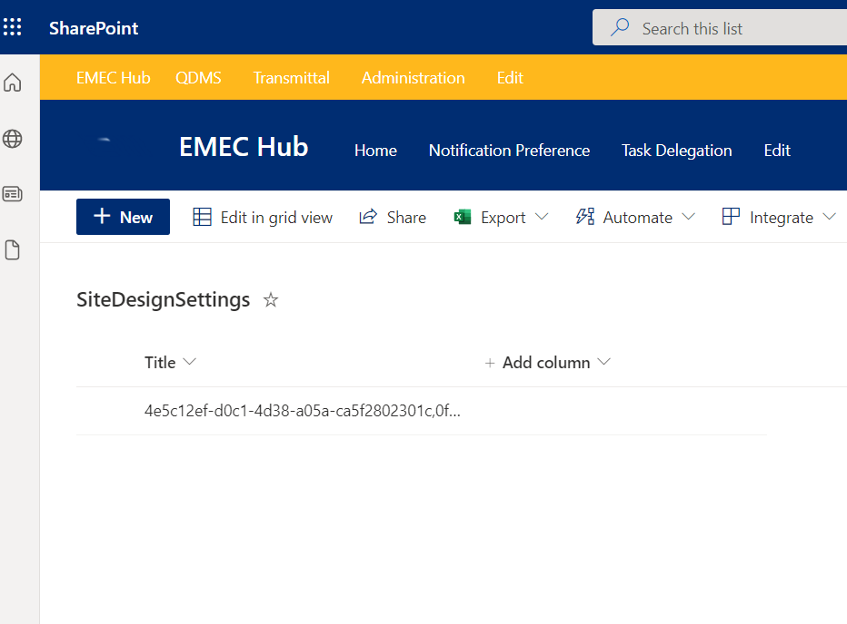

The rest of the provisioning part is handled by Logic App flow.

For further reference visit: <https://docs.microsoft.com/en-us/sharepoint/dev/declarative-customization/site-design-overview>

If there is an error when spo is not working, go to

**C:\Windows\Microsoft.NET\assembly\GAC_MSIL**

Delete SharePoint files and re install SP service module

Then->

Uninstall-Module -Name Microsoft.Online.SharePoint.PowerShell -AllVersions -Force

If you want to update the modules

Update-Module -Name Microsoft.Online.SharePoint.PowerShell

https://www.sharepointdiary.com/2016/08/sharepoint-online-remove-user-from-site-collection-using-powershell.html